Day 3 — Building AI Applications & AI Agents
Duration: 4 Hours
Lab Title: Build a RAG Chatbot and AI Agent using Azure AI Foundry

Lab Objectives
By the end of this lab, you will be able to:
- Understand AI Agent fundamentals.
- Configure an LLM application.
- Build a RAG chatbot using the Azure UI.
- Create and configure an AI Agent.
- Connect knowledge and tools to an agent.
- Test the AI application and agent.

Hands-on Lab — 15 UI-Based Steps

Step 1 — Open Azure AI Foundry
- Sign in to the Azure Portal.
- Open Azure AI Foundry.
- Open the existing project created for the lab.
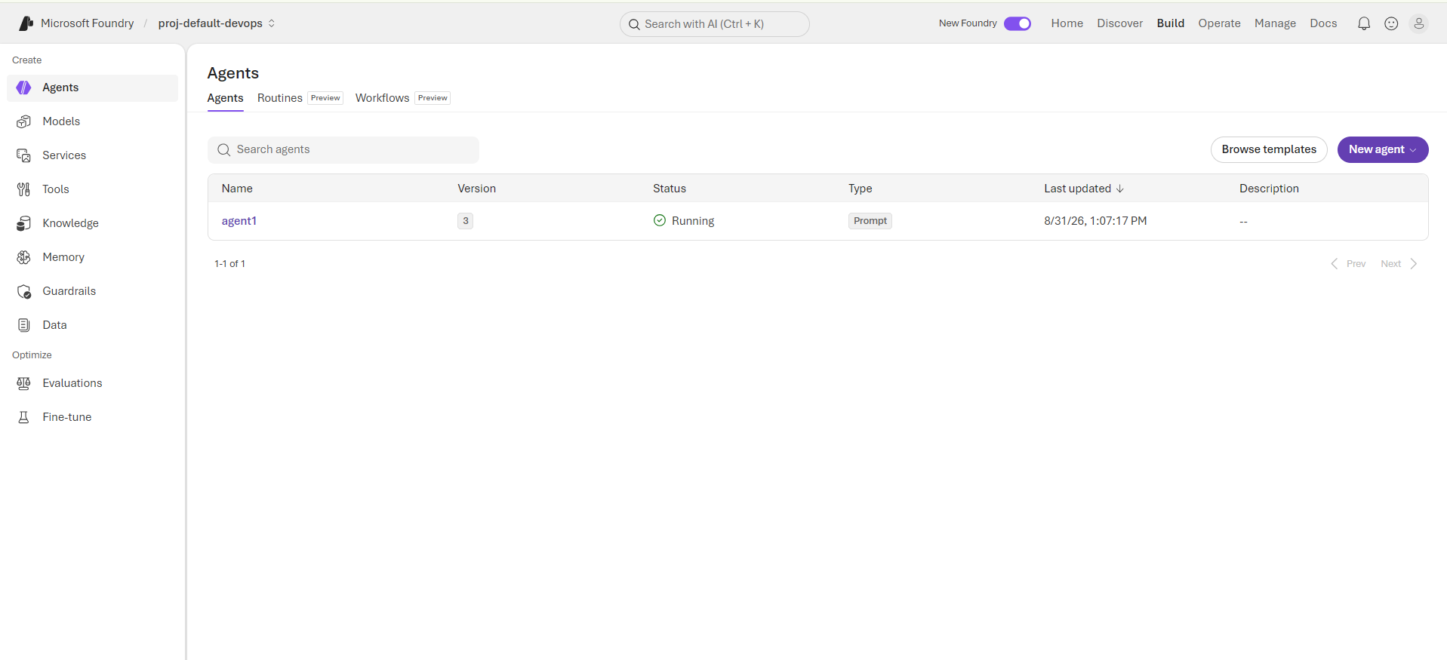

Step 2 — Verify the LLM Deployment
- From the project, select Models + endpoints.
- Locate the GPT model deployed during Day 2.
- Verify that its status is Succeeded.
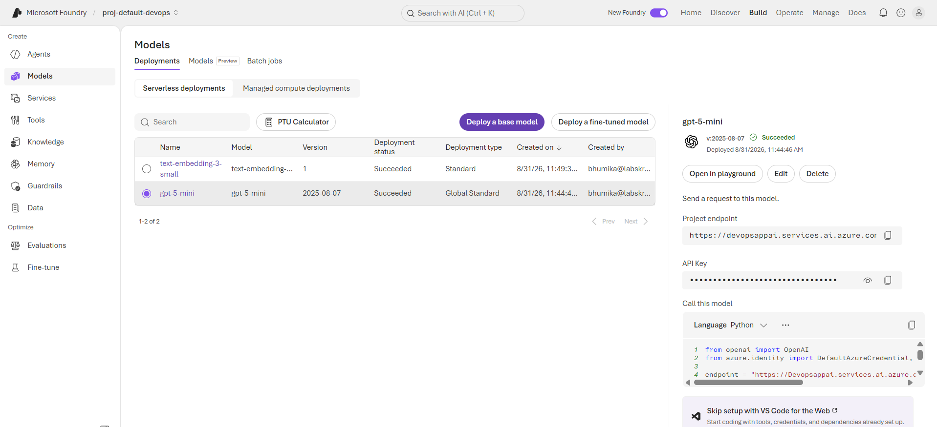
Step 3 — Open model
- select Playgrounds.
- Select Chat playground.
- Select the deployed GPT model.
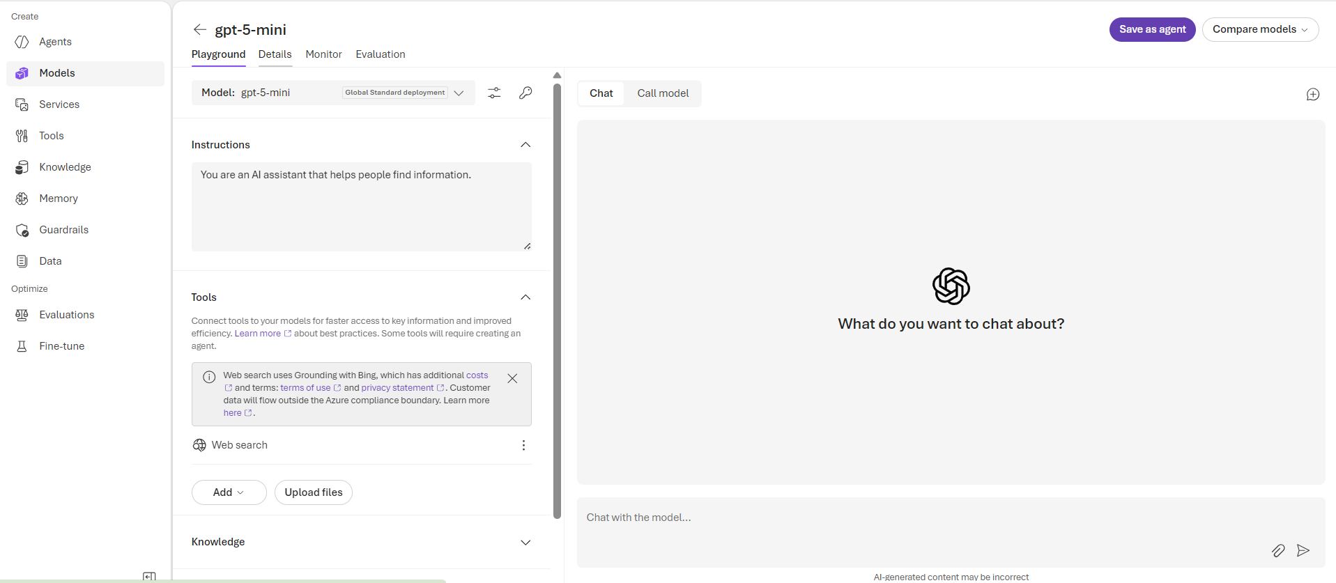

Step 4 — Configure System Instructions
In the System message / Instructions area, enter:
You are an Azure AI assistant. Answer questions clearly and use the provided knowledge when available.
Send a test question and observe the response.

Step 5 — Test Prompt Engineering
Enter:
Explain Retrieval Augmented Generation to a beginner.
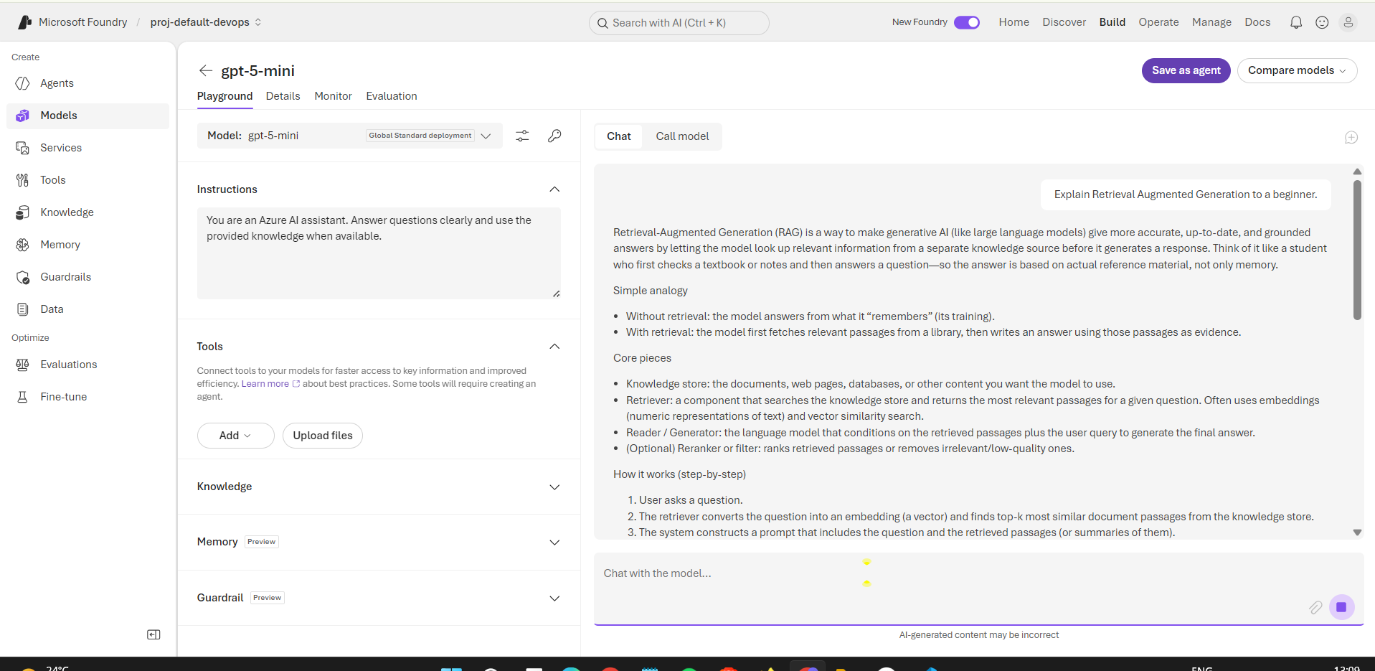
Modify the prompt to:
Explain Retrieval Augmented Generation to a beginner using a simple Azure example.
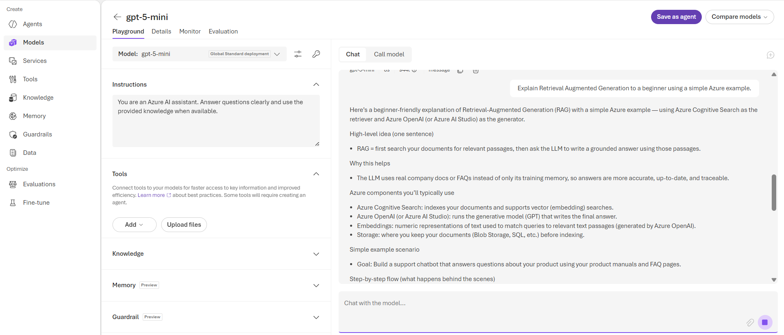
Compare the two responses.

Step 6 — Open the Knowledge Configuration
- Open the Knowledge or Add knowledge option in the Foundry interface.
- Select the available knowledge connection from the Day 2 lab.

Step 7 — Connect Azure AI Search
- Select Azure AI Search.
- Select the existing Search resource.
- Select the existing RAG index/knowledge source.
- Select Connect.
The Day 2 lab already creates the Search index and knowledge source, so these resources are reused here.
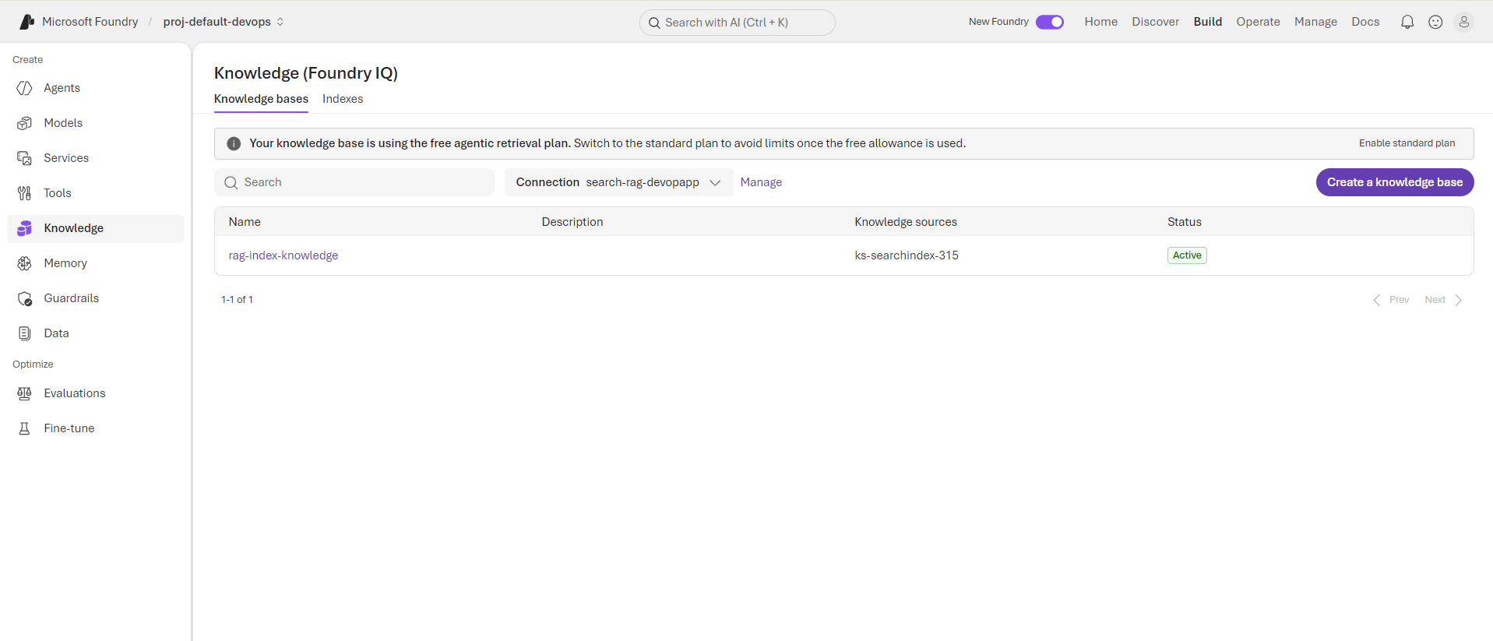

Step 8 — Open Agents
- Return to the Azure AI Foundry project.
- Select Agents.
- Select Create agent.

Step 11 — Configure the AI Agent
Provide:
Agent Name:
Day3-Azure-Agent
Select the existing deployed GPT model.

Step 12 — Add Agent Instructions
Enter:
You are an Azure AI training assistant. Use the available knowledge to answer questions. If information is unavailable, clearly state that it is not available. Do not invent facts.
Save the configuration.
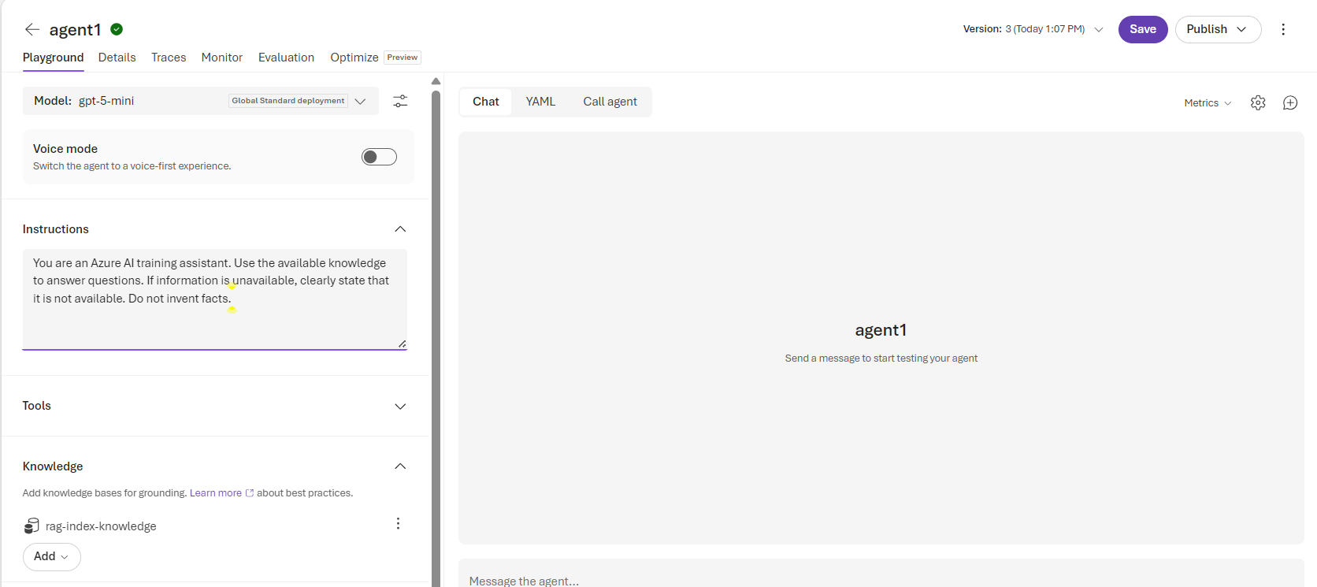
Step 13 — Add Knowledge to the Agent
- Open the agent's Knowledge section.
- Select Add knowledge.
- Select the existing Azure AI Search/knowledge source.
- Select Connect.
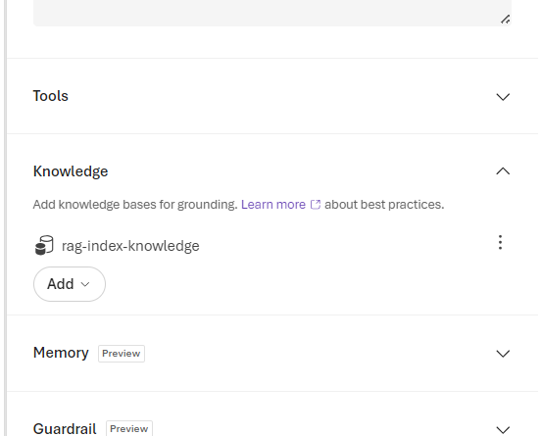
This builds on the knowledge-to-agent connection already introduced in Day 2.

Step 14 — Configure a Tool(if needed)
- Open the agent's Tools section.
- Select an available tool/action supported by the lab environment.
- Configure the tool.
- Save the agent.
Explain that:
Knowledge → provides information
Tools → allow the agent to perform actions

Step 15 — Test the AI Agent
Open the Agent Playground/Test interface.
Test:
Explain Retrieval Augmented Generation.
Then:
What is the difference between RAG and an AI Agent?
With knowledge base connected:
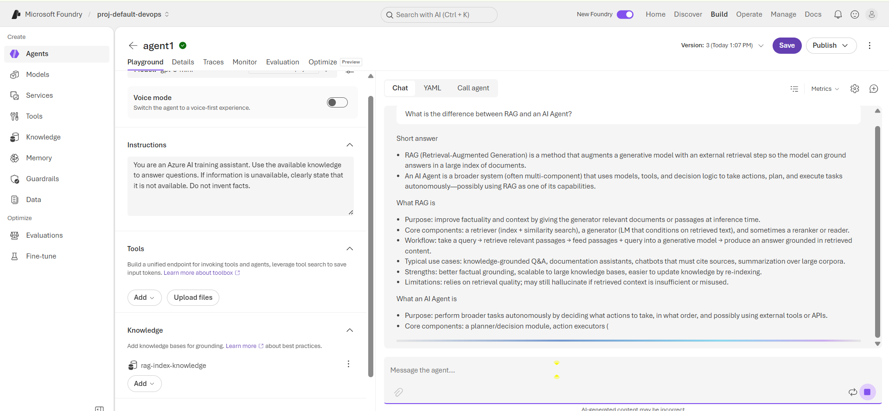
Finally, ask a question outside the provided knowledge.
Verify that the agent uses its instructions, knowledge, tools, and GPT model to generate the response.

